**User Experience and Tool Usability Questionnaire**

Response ID: 15

This questionnaire was designed to gather user feedback on the usability and effectiveness of the SOFL-ASMAT.

Respondent Profile

* 1. What is your highest level of education (please select the highest level, including those currently in progress)?

Associate’s degree

* 2. What is your current occupation?

Developer

* 3. How many years of experience do you have in software development?

2-5 years

* 4. How familiar are you with SOFL formal specifications?

Beginner

* 5. Have you previously used automated tools for software maintainability assessment?

Yes

* 6. Are you familiar with the ATM system used in this experiment?

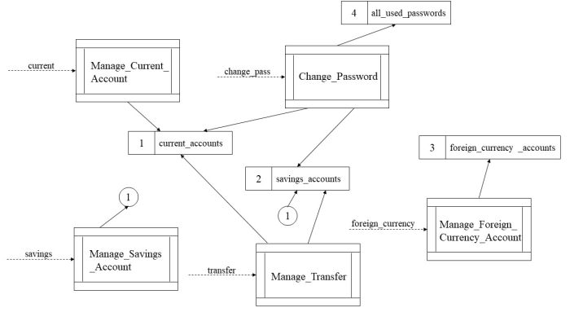

[Likert-scale item]

Unfamiliar（2）

Tool Usability and User Experience

* 7. Do you think it is easy to find the navigation bar in the interface and use the tool? [Likert-scale item]

图形用户界面, 树状图

AI 生成的内容可能不正确。

Neutral（3）

* 8. Are you satisfied with the clarity and completeness of the instructions provided in the tool’s navigation menu? [Likert-scale item] 图形用户界面, 应用程序, Teams

AI 生成的内容可能不正确。

Satisfied（4）

Interface and Interaction

* 9. Do you find the tool’s metric interface intuitive? [Likert-scale item] 图形用户界面, 应用程序

AI 生成的内容可能不正确。

Neutral（3）

* 10. Do you find the visualization of metric data helpful in assessing maintainability? [Likert-scale item]

图形用户界面, 应用程序

AI 生成的内容可能不正确。

Neutral（3）

Efficiency

* 11. How long does it take you to assess the maintainability of SOFL specifications (around 1000 lines)?

0.5-2 hours

* 12. Based on your experience, how would you rate the tool’s efficiency in assessing the maintainability of SOFL specifications? [Likert-scale item] 图形用户界面, 表格

AI 生成的内容可能不正确。

Neutral（3）

* 13. Do you think this tool has saved you time compared to manual evaluation? [Likert-scale item]

Neutral（3）

Practicality

* 14. Do you find the tool useful in assessing the maintainability of SOFL specifications?

[Likert-scale item]

图形用户界面, 文本, 应用程序

AI 生成的内容可能不正确。

Neutral（3）

* 15. Would you recommend this tool to other developers or teams? [Likert-scale item]

Uncertain（3）

* 16. Overall, do you think the tool satisfied your needs? [Likert-scale item]

Neutral（3）

17. What do you think are the advantages and disadvantages of this tool? (Open-ended)

(No valid responses)